
Thwaites School – Half-Termly Newsletter - Summer
An Introduction
Hello and welcome to the fifth edition of the Thwaites School half-termly newsletter. What an incredibly busy half-term we have had. It’s hard to believe that we only have one half-term left until the end of the school year. There has been a lot of exciting things happening in school this half-term including planting bulbs, digging for worms, overnight residentials and the official opening of the ‘Thwaites School Values Shop’. All of this on top of our usual exciting curriculum. Read on to find out more.

Class One
In Class One the children have been enjoying their learning based on the theme, ‘Beside the Seaside, Beside the Sea’. They have been reading a story called ‘The Storm Whale’ and developing their prediction skills to talk about what the book might be about as well as learning new vocabulary linked to the text. In Design and Technology, the children designed and made a French picnic which they enjoyed on a trip to the beach. In science children have learnt about the life cycle of frogs and enjoyed playing with small world toys in their water tray linked to this topic. The class have also developed their gymnastics and tennis skills in PE and have found out about different leaders in RE.
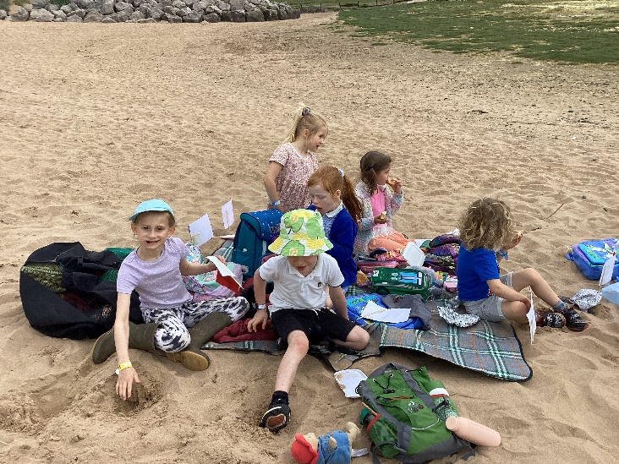
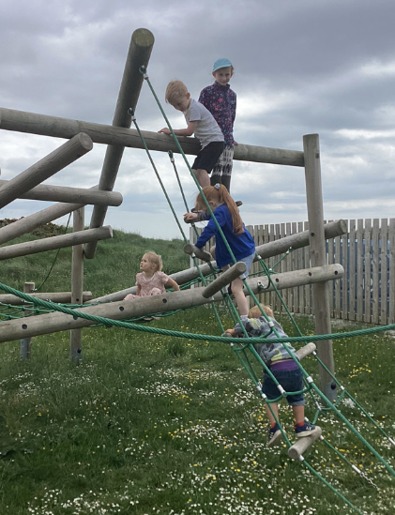
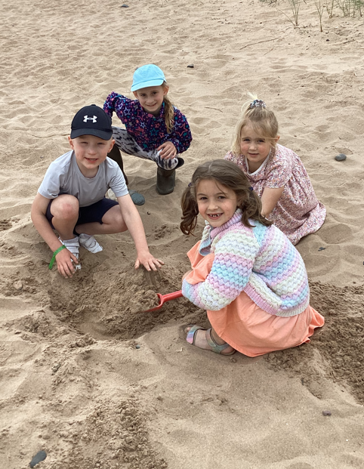

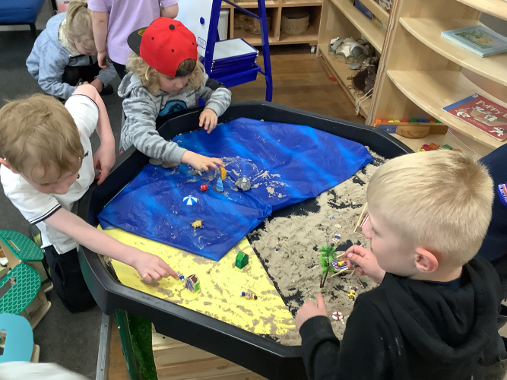
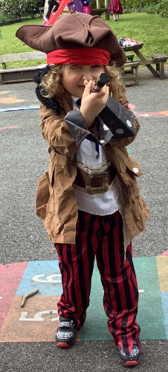
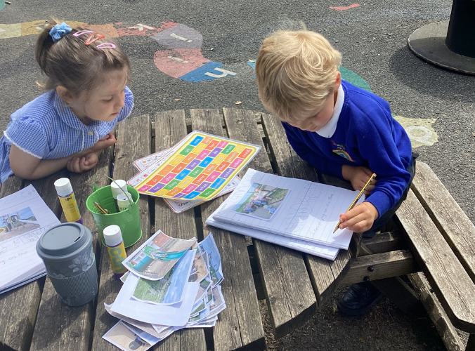

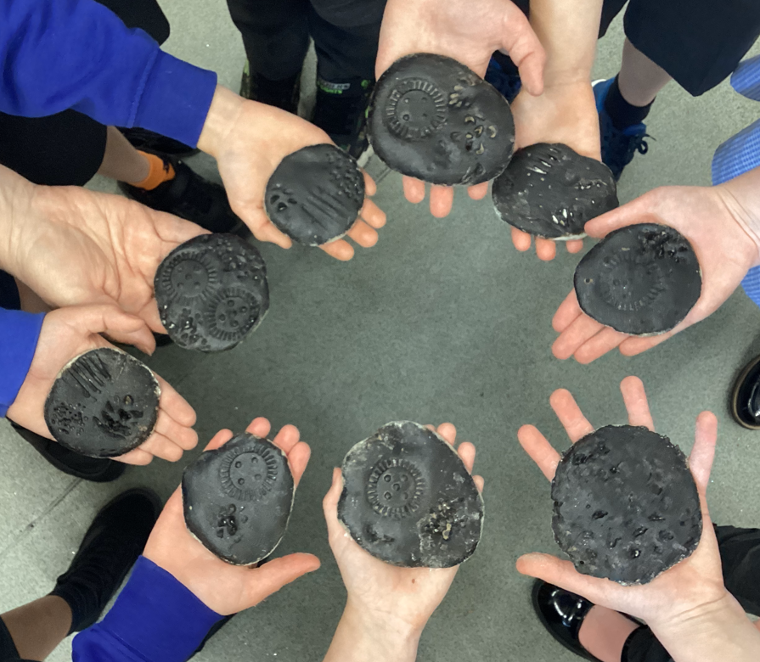
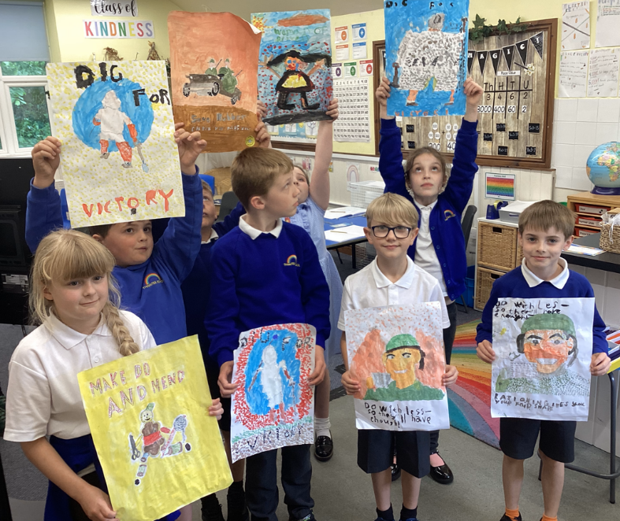
Class Two
Class Two have been working on the topic of ‘World War II’. As well as learning all about this in History and they have also been enjoying the book, ‘The Lion, The Witch and The Wardrobe’, which they have based their writing on this half-term, producing story and a book review. The children have really enjoyed creating propaganda posters in the artistic style of pointillism and pop art, which are displayed in the school. They have enjoyed learning all about rocks and how they are formed in Science, making their own fossils from coffee, salt and flour, and have enjoyed playing and singing rock and roll in music. They also had an amazing time on their overnight residential at the fantastic Low Bank Ground, (you can read more about this later) and honed their tennis and rounders skills in PE.

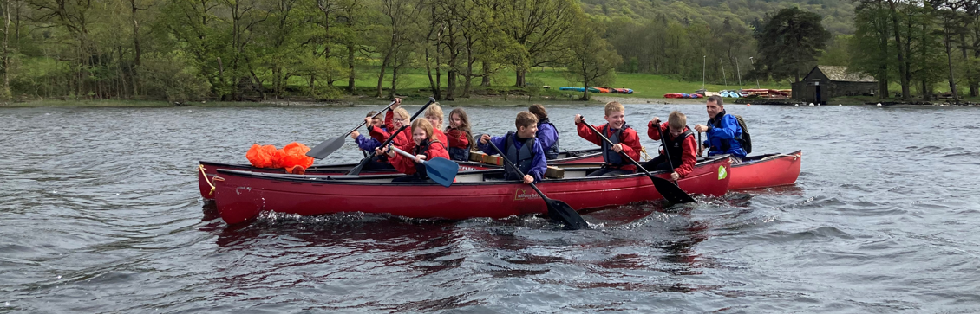
Low Bank Ground
This half-term, Mr. Redhead, Mrs. Ross and Mrs. Holmes took the Class Two children on a two-day overnight residential at Low Bank Ground, on the shores of Coniston Lake. The first day the children enjoyed a walk in the hills before canoeing across the lake to enjoy an ice cream on the shore. After a good night’s sleep (ha, ha!) and a hearty breakfast, the children then went ghyll scrambling for the day before returning to school. All of the children displayed bravery, caring and teamwork and everyone had a fantastic time, making memories that we are sure they will carry with them always.

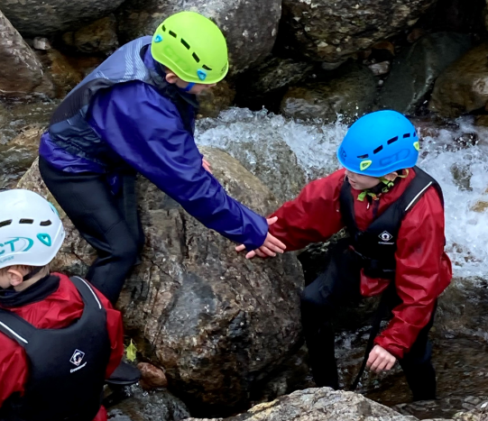
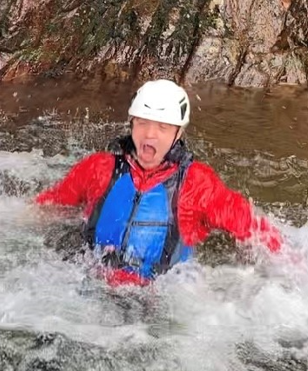
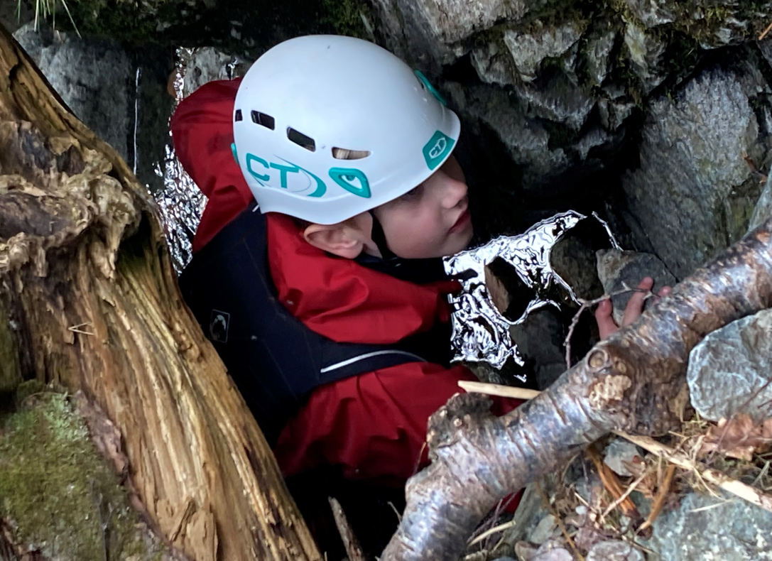
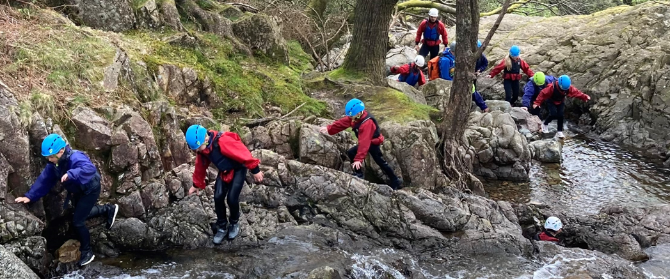
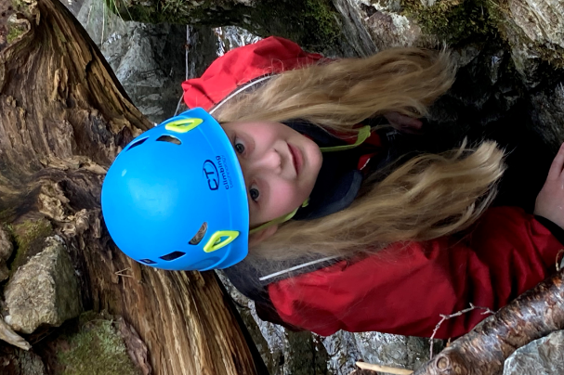

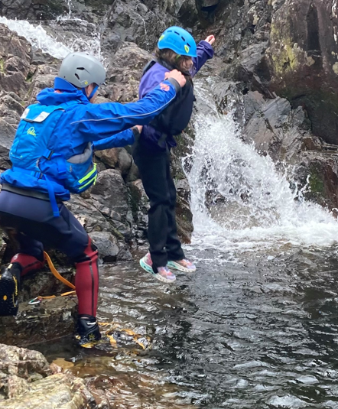
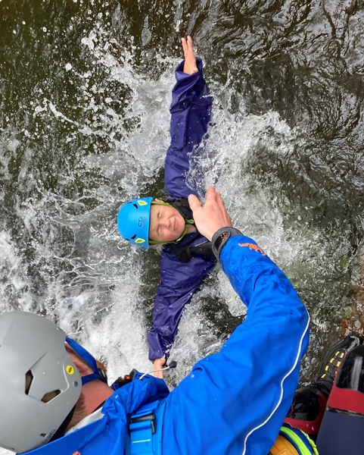
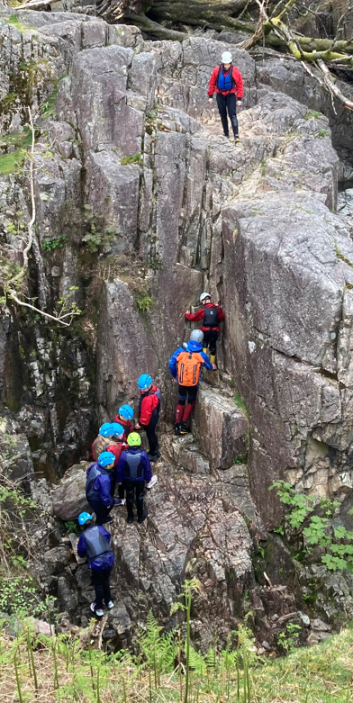

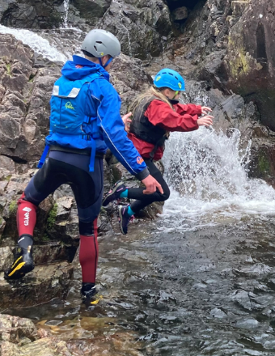
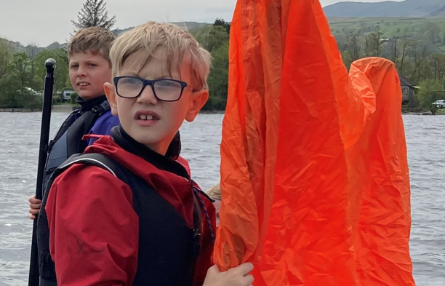

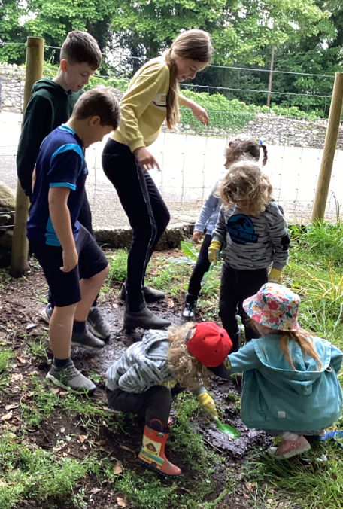
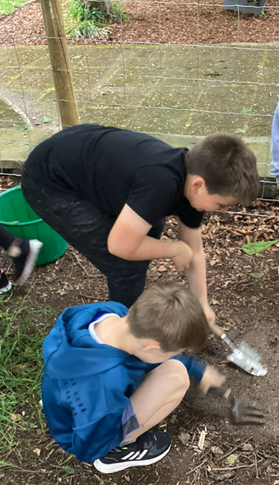
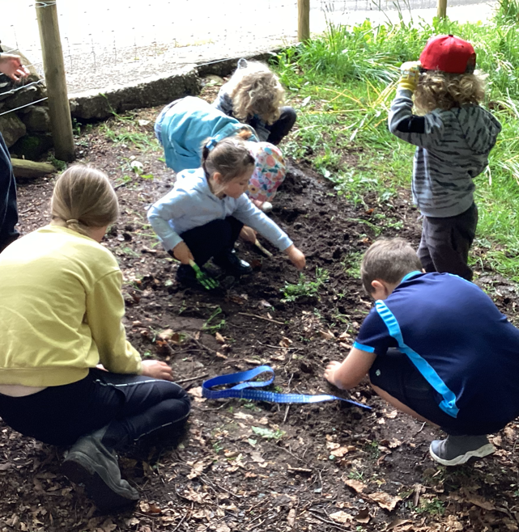
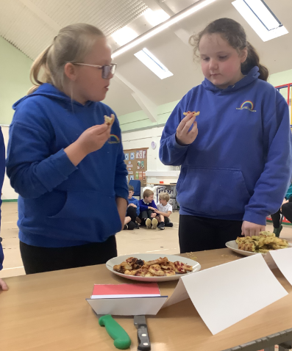
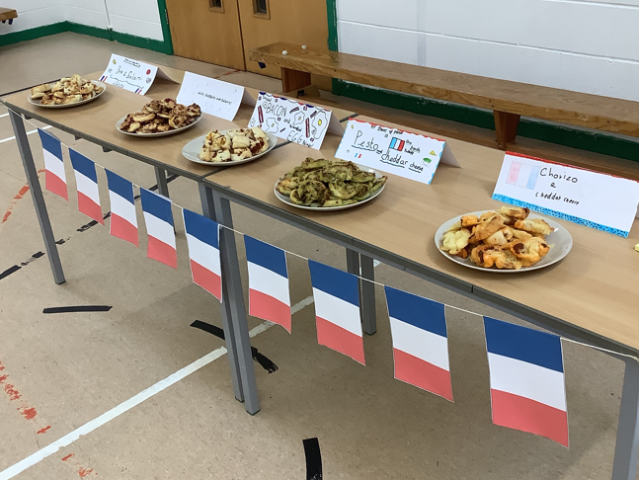
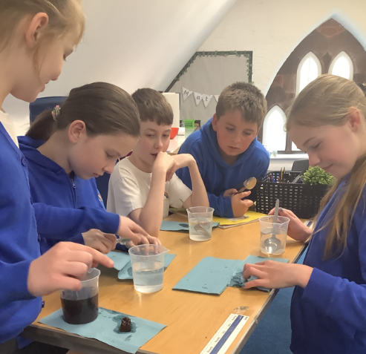
Gardening Day
The community environmental group continue their excellent support of the school and this half-term John Sutton led a full morning of bulb planting and worm counting for all of the children, staff and parents of Thwaites School. We can’t wait to see the wild flowers bloom and the school was awarded a certificate to show we took part in the Soil Association Worm Hunt. We would like to say a huge thank you to John, the community environment group and to any parents and carers who helped on the day.
Class Three
Class Three have been enjoying the theme, ‘Food, Glorious Food’. The children have designed and made delicious palmiers, linked to the French food they have been learning about in French, which they baked in the last week before half-term, before asking the children and staff in school to judge their favourites. The winning flavour was brie and salami. In geography, the class have been investigating London, ready for their exciting London visit after half-term and created posters using the information they discovered. The class have also been learning about film making in computing, linked to film music which they have been learning about in their music lessons. The children have been conducting and filming interviews throughout the school to gather information about school dinners. This half-term also involved SATS week and Miss. Jordan would like to say a huge well done to all of the year six children for their hard work and maturity leading up to, and during, the SATS week.

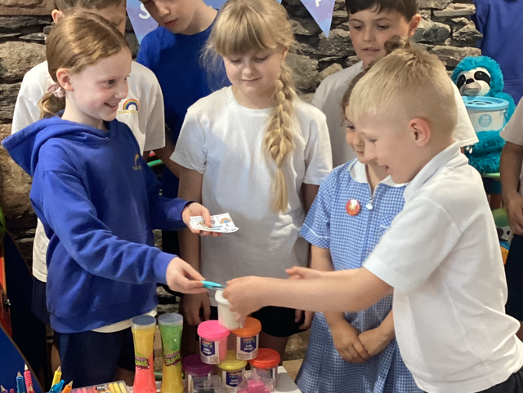
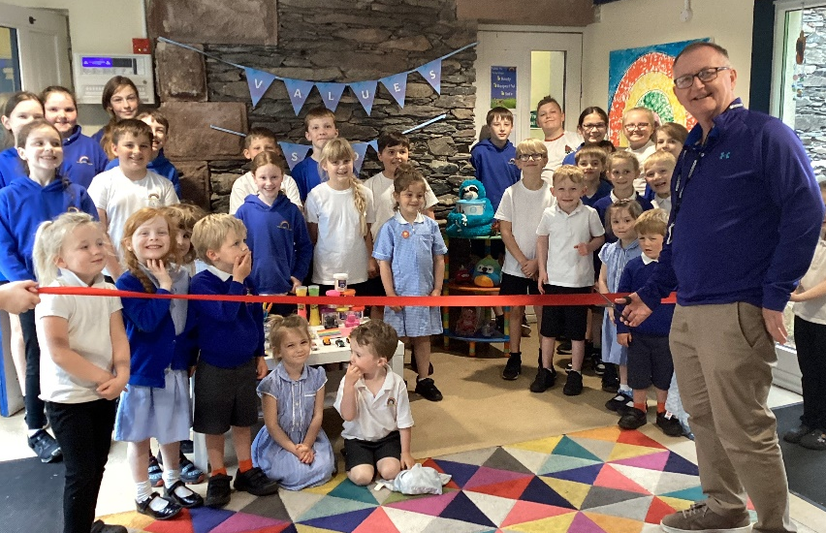
Thwaites School Values Shop
This half-term the vice-chair of governors, Mr. Savage, kindly visited school to officially open the ‘Thwaites School Values Shop’, our school-based shop full of toys and stationary for the children to buy. The school has its very own currency, the ‘Rainbow Note’ that children earn if they display one of our school values of honesty, inclusivity, empathy, enthusiasm, resilience and aspiration. Children are able to buy small value items, such as notebooks, pens and pencils or save up for more expensive items, such as cuddly toys and LEGO kits. The children are very excited about the shop and gave a huge cheer when Mr. Savage cut the red ribbon. The shop keepers then served the shop’s very first customer who had saved his five rainbow notes to buy a brand-new blue pen.

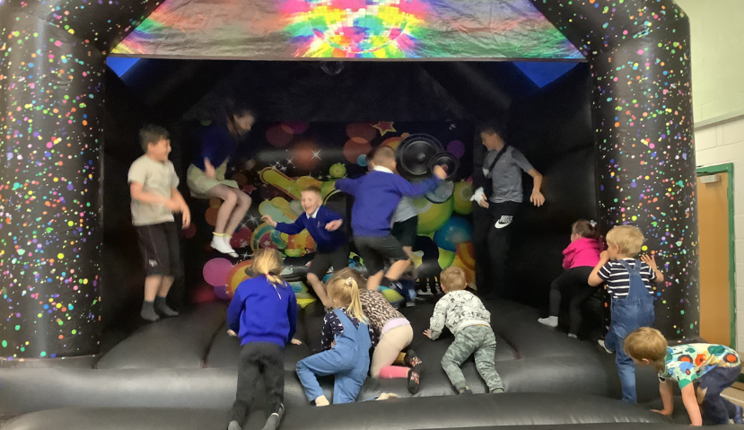
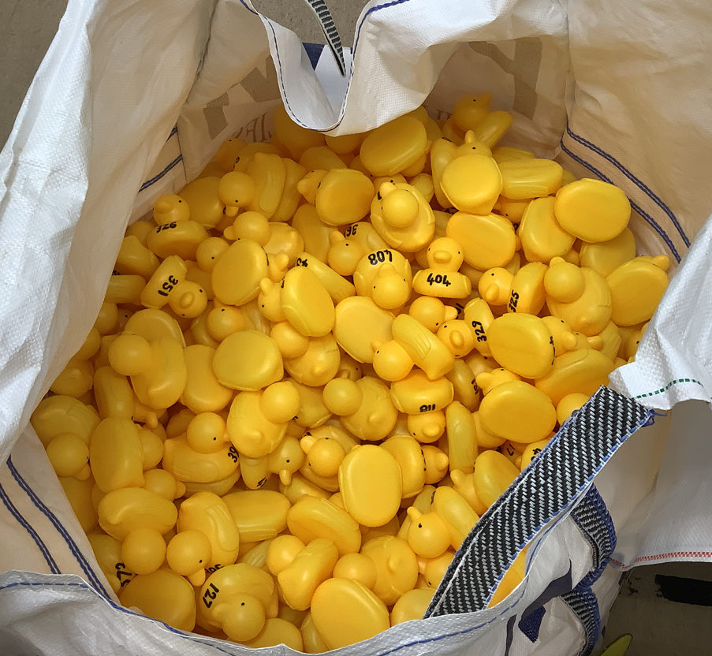
Duck Race
The Duck Race, organised by Emily and Tony Barrow, to raise funds for Thwaites School was a huge success, despite the duck race not actually going ahead. The event moved to the school hall at the last minute due to the unpredictable English weather and children and adults enjoyed a bouncy castle, a raffle, a cake stall and all the sausage buns they could eat. Mr. Redhead pulled the ducks out of a huge bag and the winners were announced. The event raised a huge £1,508.10 for the school which is a fantastic amount. Thwaites School would like to thank Emily and Tony Barrow for organising the event, all the volunteers who helped out, the local businesses and community members who donated prizes and parents and carers who attended. It really was a wonderful community event that we hope to repeat in the future.



Thank You
As always, we would like to wish all of our Thwaites families a huge thank you for your ongoing support.
Dates for Your Diary – Details will follow closer to each date
- Monday 3rd June – Back to school after half-term break
- Thursday 6th June – Children and family photos
- Monday 10th June – Wednesday 12th June – Class Three go to London
- Monday 17th June – Friday 28th June – Class Three go swimming
- Monday 24th June – Year Six day at John Ruskin School
- Thursday 27th June – Year Five day at Millom School
- Friday 28th June – End of year reports go out
- Wednesday 3rd July – Year Six den building day at Black Combe Junior School
- Thursday 6th July – Sports Day
- Friday 7th July – Year Six day at Millom School
- Friday 12th July – End of year awards ceremony at the Village Hall
- Thursday 18th July – Summer Fete
- Friday 19th July – Break up for summer break
Thwaites Gala
On Saturday 8th June, the ever -popular Thwaites Gala will be taking place at the Village Hall and Thwaites School will be in attendance with the school bus so come over and say hi if you are there. The king and queen of the gala will be there and our very own Miss. Jordan will be starting the races. As well as all of the usual wonderful stalls and attractions, there will also be the ‘Dick Barrow – Garden on a Plate’ competition that all Thwaites School children are welcome to enter, so get creating and make sure you drop your entrants off at the gala bright and early so that they can be set out for judging. We hope to see you there.

Extra-Curricular Activities
After half-term we will be offering some brand-new extra-curricular activities either after-school or at lunchtime. If your child wishes to attend one or more of the activities available then please return the permission slip below as soon as we return back to school after half-term. The after-school clubs will run from the end of the school day until 4:00 p.m.
There is currently no limit to the numbers that can attend the clubs but this is subject to change if numbers for certain clubs are too high. Parents and carers will be informed once all permission slips are in if their child/children are in the clubs they hoped to be.
The list of clubs are as follows:
Monday After School:
STEM (Science, Technology, Engineering and Maths) Club with Miss. Jordan
Tuesday Lunchtime:
LEGO Club with Mr. Redhead
Tuesday After School:
Dance Aerobics Club with Mrs. Ross
Thursday After School:
Book Club with Mr. Redhead
Please complete the permission slip below and return it to school as soon as possible, after half-term.
Important Note: The clubs will not begin until the second week after half-term.

My child would like to attend the following clubs: (Tick the appropriate boxes)
STEM Club |  | Dance Aerobics Club
LEGO Club |  | Book Club

Name of Child:
I understand that the after-school clubs finish at 4:00 p.m. and that it is my responsibility to collect or arrange collection of my child at this time.
Parent/Carer Signature:

